BERKELEY WATER ACTION PLAN

*Preliminary;* December 2013

**Introduction and Background**

Water is an increasingly scarce resource in California, due to population growth and drought. In past years, the East Bay Municipal Utility District (EBMUD) has declared droughts and implemented drought management plans that seek to reduce regional water use. Water conservation is also important given the energy associated with the transportation, treatment, and use of water.

A concerted water conservation effort by the campus is environmentally beneficial, improves aging fixtures and equipment, reduces campus risks associated with rationing measures during drought years, and hedges annual water price escalation. Concerns about water conservation and the possibility of future water rationing or price increases prompted the Chancellor’s Advisory Committee on Sustainability (CACS) to commission a water usage and conservation report in 2009 (included as Appendix A). In spring 2010, the CACS Co-Chairs and Vice Chancellor Denton presented the CACS water reduction recommendations and supporting financial and project documentation to Chancellor Birgeneau. In spring 2011, the Chancellor set a goal to reduce potable water use to 10% below 2008 levels by 2020.

In September 2012, the UC system also set goals applicable to all campuses, including to reduce potable water consumption adjusted for population growth[1] by 20% by 2020, with each campus setting its own three-year baseline. This target will be re-evaluated as necessary by the Sustainable Water Systems Working Group. UC Berkeley has developed this Water Action Plan, which identifies current strategies for achieving sustainable water systems, as part of the requirements of the new water conservation policy. A campus working group will be created and will identify potential future strategies for review and consideration.

**Berkeley Goal**

Reduce potable water use to 10% below 2008 levels by 2020. Double the reduction target if the local utility provides a non-potable source of water for irrigation.

**System-Wide Goal**

Reduce potable water consumption adjusted for population growth by 20% by the year 2020. (UC Berkeley baseline: Average over FY2003-2005)

UC Berkeley’s water use goals are summarized above. **The campus has already achieved the system-wide goal and is on track to reach the campus one by 2020**, and will continue to implement priority water conservation and education projects, as outlined in this plan.

In addition to water consumption goals, UC Berkeley recognizes campus impacts on water quality within its own watersheds (Strawberry Creek, Codornices Creek, Claremont Creek and several others) as well as the potential harm from chemicals discharged to the campus sanitary sewer system.

Laws and regulations addressing these water quality impacts are becoming increasingly stringent, and the campus has devoted significant resources to not only meet these requirements but to exceed them in many areas. Through training and outreach to the Campus community, understanding of these issues and the steps needed to address them is increasing, spurring innovation and action.

**Benchmarking and Previous Studies** (excerpted from Appendix A)

Benchmarking research focused on other large universities’ water usage profiles. Water consumption at a range of universities was examined, including other research institutions and universities who have successfully reduced their consumption[2]. Total water usage by institutions of higher education varies substantially by size, location and climate, efficiency of water usage, and other factors.

It was not possible, however, to accurately analyze UC Berkeley’s usage against these benchmarks. Not all universities report water consumption and not all use the same protocol for reporting usage[3]. In addition, there has been limited analysis of broad water usage patterns in higher education.

It was possible to examine best practices at other universities. The most common steps being taken by universities are one with a relatively low upfront cost: education and outreach, enhanced leak detection and repair, improved irrigation practices, and installation of low-flow domestic fixtures (toilets, faucets, and showers). There are also examples of institutions that have reduced water usage in laundries and cooling towers or who have found ways to expand the use of non-potable water (e.g., through water reuse or rainwater capture).

There were few schools, however, who had found it economical to convert all domestic features to low flow or to implement some of the more costly projects (e.g. conversion of all cooling towers to a closed loop system). All such universities identified in this analysis were located in the southeastern United States. Otherwise, schools reported that relatively low water pricing meant that the financial feasibility of many projects was not sufficient for implementation.

There are rich resources of past studies, projects, policies and educational programs regarding water at U.C. Berkeley. One of the key documents evaluated is the “A Sustainable Water Plan for the University of California Berkeley” by Jubilee Daniels[4]. In the report, Daniels covered historic and current water use and disposal, campus sustainability policies, main campus water audit and result, the residence halls water audit and result, and case studies of water conservation and reuse with new development and major renovations.

**Current Water Use**

**Total Potable Water Use Declines**

Historical potable water consumption data have been collected and compiled from multiple sources. The data presented in this section include the nine main campus meters covering an area approximately bounded by Hearst Avenue, Piedmont Avenue, Bancroft Way, and Oxford Street. In addition, use at residence halls and 98 additional water accounts (excluding LBNL use) outside of the main campus boundary was included.

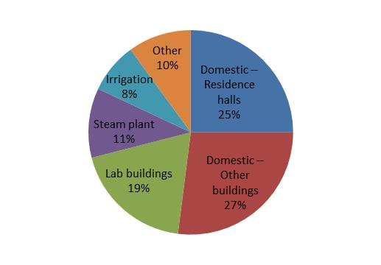

About half of the water consumed on campus is domestic (toilets, urinals, showers, and faucets), divided equally between residence halls and all other campus buildings. About one-fifth of usage is in lab buildings (excluding their domestic usage), with irrigation and the steam plant each using about 10% of the total. Over 90% of irrigation systems are automated and connected to a weather station.

A more detailed discussion of how these source allocations were estimated can be found in the feasibility study in Appendix A.

Berkeley currently uses over 615 million gallons a year of potable water. **The campus has already achieved the system-wide reduction target and is on track to reach the campus one by 2020.** Total potable water use increased by 2.4% in 2012 but is still down 6.0% since 2008. Water use per WCU has dropped by 20.0% relative to the average use between 2003-2005 (18,851 gallons), even given increases in square footage. Furthermore, water use per WCU has dropped by 34% since 1995.

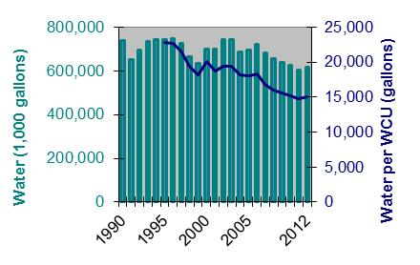

|  |  |  |  |  |  |  |  |
| --- | --- | --- | --- | --- | --- | --- | --- |
| **Potable Water, 1990-2012** | | | | | | | |
|  | **1990** | **1995** | **2000** | **2009** | **2010** | **2011** | **2012** |
| Water  (millions of gallons) | 739.3 | 744.8 | 698.7 | 639.9 | 624.7 | 602.1 | 616.3 |
| Weighted campus user[5] | n/a | 32,704 | 34,725 | 41,139 | 41,025 | 40,658 | 40,984 |
| Water per WCU (gallons) | n/a | 22,773 | 20,121 | 15,554 | 15,227 | 14,808 | 15,037 |
| Wastewater  (millions of gallons) | 546.7 | 512.2 | 473.9 | 451.7 | 452.8 | 421.5 | 431.4 |

**Residence Hall Water Use Declines**

Water use in residence halls, adjusted for the number of residents, has declined by over 35% in the last ten years. While new residence halls have been built to address affordability concerns, efforts have been made to install more water-efficient technologies and to encourage residents to use less water have contributed to this unexpected decline.

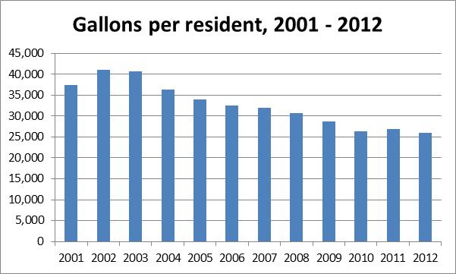

**Reuse and Recycling Options**

There is no substantial source of non-potable water on campus[6]. The campus will continue to monitor whether the East Bay Municipal Water District (EBMUD) – who provides all of the potable water used by campus – can also provide reclaimed water to the campus, but there has been no formal commitment by EBMUD to do so.

**Action To Date**

The campus has already taken numerous actions to reduce water use on campus and to raise awareness about water issues. Some of these projects were funded through The Green Initiative Fund or the Chancellor’s Advisory Committee on Sustainability (CACS) Green Fund Grants. The actions fall into four categories: technology upgrades, irrigation-related, behavior change, and water quality improvements. Additional information on the costs and water savings associated with these projects will be compiled at a future date.

***Water Conservation: Technology***

**Water Improvements Come with LEED™ Renovations** In general, all new construction and major renovation projects will maximize the number of water use reduction credits as part of the LEED™ certification process, but two recent LEED™ certified projects made notable changes to the way water is sourced and used. University Village in Albany is now piped to utilize recycled or reclaimed water for irrigation once the local municipal water agency makes it available (currently scheduled for 2012). Another one of the finished LEED™ renovations, Morgan Hall Laboratory, reduced its expected water usage by over 40% with new water saving technology/low flow installations.

**40% water reduction after Clark Kerr Campus renovation** Compared to baseline building and occupant models, post-renovation water consumption in the Clark Kerr Campus Renewal Phase 1 buildings has been reduced by 40%. This has been achieved through the selection of water efficient fixtures such as dual flush water toilets in dormitories and in suites, 0.5 gpm lavatory faucets, 1.5 gpm showerheads, and 1.5 gpm kitchen faucets. In addition to the reduction in building water usage, the project incorporated landscape features that reduce the need for irrigation, a retention basin that receives stormwater from adjacent landscaping, pervious pavement, roof leaders, and an upgraded storm drain system. Most of these features will be replicated in the second Phase of the renovation.

**Real-time Water Metering Informs Campus Water Conservation Efforts**

The [Water Metering projects](http://tgifberkeley.com/index.php/funded-projects/projectthemes/51-watermeteringconservation) installed and upgraded meters in 67 buildings with the help of PP-CS, connecting these meters to the campus Obvius server so that real-time metering updates can be viewed online. The project leaders also collaborated with PP-CS on connecting electric and steam meters to Obvius in Barrows, Birge, Boalt, California, Cory, and Simon Halls. They conducted a water audit on every toilet and urinal in Wurster Hall using ultrasonic water meters to determine gallons of water per flush, finding that that 71% of fixtures use more than their rated 1.6 gallons per flush, around 2-4 g/flush, with several at 5 gallons per flush. The sub-meter data will be used for leak detection and occupancy use.

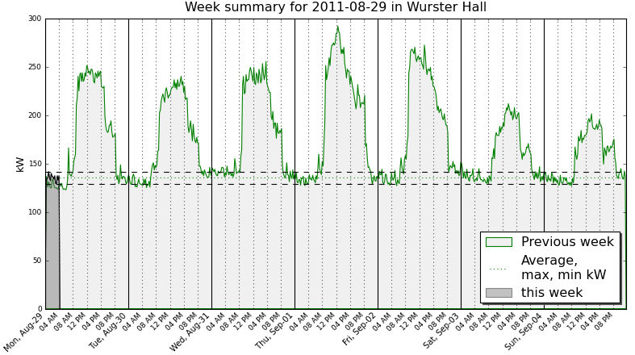The Water Metering and Sub-metering project and the Water Metering and Conservation project were not without their challenges. The project leaders had intended to replace ten fixtures in the Wurster bathrooms with ten water efficient and dual flush fixtures, but the equipment slated for installation did not match PP-CS's required fixtures. Because the fixture installations were not completed, a post-water efficiency audit was not feasible for the Wurster fixtures.  (excerpt from project TGIF [website](http://tgifberkeley.com/index.php/funded-projects/projectthemes/51-watermeteringconservation))

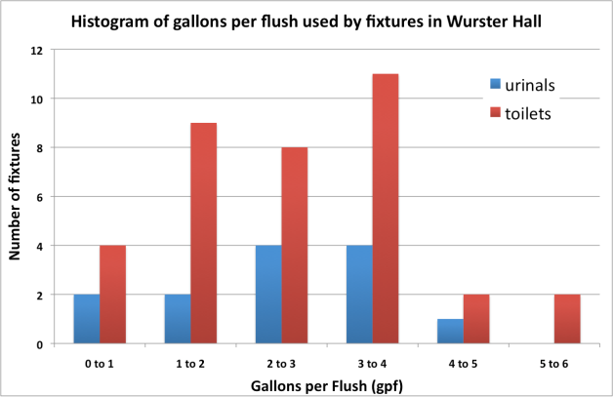

**Campus Plumbers Reduce Water Use by 17%** By altering 57 toilets and urinals to use less water, plumbers Nick Pigati, Diane Coppini, and Eric Lausen reduced water consumption in University Hall by 17% or 33,000 gallons per year. They used a simple conversion kit (rather than replacing the fixtures) to reduce the gallons per flush from 3.5 to 1.6.

***Water Conservation: Irrigation***

**Boalt Law School In-fill Project Rainwater Catchment for Irrigation** This recent project was the first on campus to capture storm runoff from impervious surfaces (rooftops and plaza) for the purpose of irrigating landscape. A 12,000 gallon tank located under the southwest stairs to the new courtyard holds runoff, which is then distributed to the various planters and landscape areas via an irrigation controller and pump.

**Low Water Irrigation Project** Physical Plant – Campus Services installed electronic metering and a weather station to provide more accurate and real-time management of campus irrigation systems.The metering will enable the campus to switch from time-base to flow-base watering. With the installation of the 4 ARAD Hydrometers, the flow rate is being monitored and measured remotely. Water usage is being recorded after irrigating the landscape to determine a baseline usage. With ongoing monitoring of the water usage, maximum and minimum set points can be established and programmed, and conditional programming features of the software will trigger alerts when flow rates exceed maximums. With the installation of an ET (evapotransipration) weather station and a Smart Controller (IRRInet-Ace) near the West Gate, local (microclimate) data is being collected and sent to the irrigation server to calculate real-time program adjustments to water schedules and upload those changes to other field controllers. The system is also automatically and remotely deactivating all campus connected controllers when sufficient rainfall is detected to prevent water waste. See TGIF [website page](http://tgifberkeley.com/index.php/funded-projects/projectthemes/30-lowwaterirrigation) for more details.

**Lawns to Meadows** This project prepared a master plan that includes locations, methodology, and plant palettes for converting selected lawns to regionally appropriate plants and promotes more efficient use of water and fossil fuel resources while respecting how open space is used. Thus far at least 14 areas, including two large lawn areas near Strawberry Creek, have been converted into meadows and the project team plans to make additional lawn to meadow conversions with anticipated water savings and reduced maintenance needs. The already converted sites feature drip irrigation (a low precipitation system), porous concrete and decomposed granite paths, pavement and stone pavers set in sand, native grassland sods, native grass blends (which only need to be mowed 1-2 times per year), organic tanbark groundcovers, seasonal flowering plants, and drought tolerant perennial plants. See photos of the Anthony Hall front lawn, before and after a spring 2013 conversion:

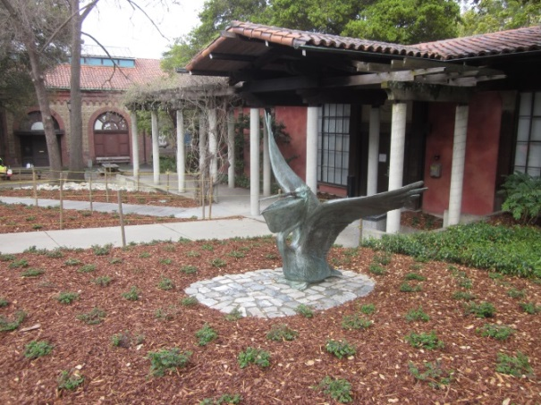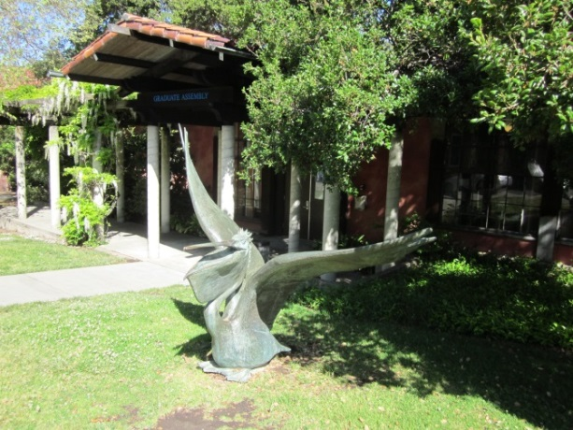

**Strawberry Fields Forever** Converting a lawn to an educational native plant landscape yielded a colorful native landscape and increased the sustainability of the landscape. The project also included educational signage.

**Water Doesn't Grow on Trees** A CACS grant updated sprinkler heads to reduce the amount of water used for irrigation and, consequently, decrease runoff into Strawberry Creek.

***Water Conservation: Behavior Change***

**PowerSave Green Campus Fights the Flow** This campaign was designed to encourage students of the Unit 1 residence halls to reduce their water consumption when taking showers, through the installation of special shower valves and educational signs. The shower valves can reduce water and natural gas consumption (used to heat water) by reducing water flow when shampooing, shaving or soaping up. In the low position, the valve allows just enough water to flow to maintain the original temperature. According to survey conducted on the residents, 82% of students in the target residence halls (Christian and Slottman) used the valves at least 20% of the time – leading to estimated savings of over 130,000 gallons of water.



# End the Cycle Sustainable Laundry Campaign PowerSave Campus also created an educational sustainable laundry campaign for students living in UC Berkeley residence halls and Family Student Housing, through two [TGIF](http://tgifberkeley.com/) grants. The Laundry Campaign educates students about how they can reduce their carbon and water footprints by altering their laundry habits. They have designed and posted static-cling laundry machine stickers that encourage machine users to use cold water/bright color settings and to air dry clothes when possible and also conducted pre-and post-implementation laundry surveys of residents to measure changes in laundry habits. See TGIF [website](http://tgifberkeley.com/index.php/funded-projects/projectthemes/41-endthecycle) [pages](http://tgif.berkeley.edu/index.php/funded-projects/grant-cycle/mini-grants/118-laundry-universityvillage) for more detail.

|  |  |  |
| --- | --- | --- |
| **Change in Laundry Behavior from** **Pre-Survey to Post-Survey** | **Residence Halls** | **Family Housing** |
| % Using Cold Wash Setting | +5.9% | +9.8% |
| % Using Delicates Setting | +11.3% | +3.6% |
| % Air Drying | +0.6% | +3.7% |

**Water Conservation in the Greek Community** This TGIF grant created a water conservation competition amongst the fraternities and sororities, the installation of water conservation retrofits and appliances, and an education & outreach program. The goal is to involve 25 houses and see an average of 15% overall water usage reduction. The project will also train house Sustainability Chairs to give educational programs to their chapters, and TGIF interns will install high-efficiency appliances and accessories (sink aerators, low-flow showerheads and dual-flush toilet adapter kits) in participating chapters that were not eligible or serviceable by EBMUD water audits. See the TGIF [website page](http://tgifberkeley.com/index.php/funded-projects/projectthemes/98-water-greeks) for more details.

***Water Quality Improvements***

**Lower Sproul Redevelopment Project/Eshleman Hall Replacement** The extensive rehabilitation and replacement project of the Lower Sproul Plaza and surrounding buildings incorporates state-of-the-art rainwater catchment to provide water for both toilet flushing and landscape irrigation. Through the use of several large tanks and special filters, stormwater will be captured from rooftops and the Lower Sproul Plaza and routed to toilets in the new Eshleman Hall. Overflow from the rainwater tank system will irrigate the newly planted rain garden just west of Chavez helping to slow and infiltrate runoff that formerly surged into Strawberry Creek via concrete pipes.

**Wastewater and Storm Water Quality**

The Campus implements both a Sanitary Sewer Management Plan (SSMP) and a Stormwater Pollution Prevention Plan (SWPPP) for all UC Berkeley owned property in the urban area including the “off-site” locations of Clark Kerr Campus, University Village in the City of Albany, and the Richmond Field Station. The object of these plans is to ensure Berkeley discharges to the sanitary sewers (for domestic and laboratory potable water use) and the storm drains (rainfall) are free of potentially harmful pollutants.

The Office of Environment, Health & Safety (EH&S) works closely with members of the campus community to reduce or eliminate the discharge of chemicals to Berkeley’s sanitary sewer system and to help prevent sanitary sewer system overflows caused by the improper disposal of food oils and grease (FOG) from campus restaurants and food facilities. The campus “Drain Disposal Restrictions” and the training of all lab personnel have helped reduce the discharge of chemicals to levels far below regulatory limits, and the campus work to develop and implement “green chemistry” principles can further reduce sanitary sewer discharge risk.

The goal of the Campus SWPPP is to eliminate all non-rainwater discharges to the storm drain system (which in turn all discharge to Strawberry Creek and the Bay). These discharges include even seemingly harmless sources of runoff such as irrigation runoff and plaza wash-downs because even these contain chlorine (for safe drinking water) as well as sediments, both of which harm aquatic life. EH&S works with construction projects and Physical Plant-Campus Services (PP-CS) personnel to ensure that storm-water leaving campus property is free from trash, sediments, oil, and other pollutants so aquatic habitat in our creeks and bay are not harmed by our activities.

As noted in the some of the project highlights earlier in this report, an important part of protecting storm-water quality and restoring the natural function of the watershed is the capture and infiltration of runoff into the water table to reduce erosion in the creeks and to provide water for trees and landscape. Campus tracks the amount of impervious surfaces and is making a major effort to reduce these high run-off areas by incorporating Low Impact Design (LID) features in all new and renovated construction projects. A new walking tour booklet highlighting some of these projects is available for download on the Strawberry Creek website (strawberrycreek.berkeley.edu) and will be available in hardcopy soon.

**Financial Analysis of Potential Reduction Strategies**

The feasibility study completed in 2009 (Appendix A) identified a set of water reduction projects that could be implemented by campus and by auxiliaries. The central campus projects would cost $1.3 to $ 1.6 million, would yield annual utility cost savings of $200,000 to $250,000, and reduce water usage by 7-8% (relative to 2008 usage). These projects are detailed in the below table; additional details on the assumptions for this financial analysis are in the original study. This analysis does not include any maintenance savings, as these were too complex to estimate.



*Note: Water meter installation is for 40 of the 50 largest buildings on campus that currently are not metered. Installation of an additional 42 meters would cover all the buildings on campus and would be optimal.*

**Action Plan**

Moving forward, Berkeley will convene a working group to regularly review and update this plan. The first meeting of the Working Group is tentatively scheduled for spring 2014, although the group has had the opportunity to review this first version of the Water Action Plan. At that meeting, a more thorough discussion of future action items and the role and mission of the Working Group will be discussed. A draft list of working group members is included in Appendix B.

**Current Activities** The Capital Renewal Committee (CRC) plans to allocate annual funding for high-priority projects that are needed to reach the potable water reduction goal. As part of the process to identify projects on campus that will ensure the long-term viability and function of campus physical assets, the CRC will fund water conservation projects either as stand-alone opportunities or as supplements to other projects in buildings where water conservation opportunities exist. For example, any remodels that include restrooms will be evaluated to see if toilet and urinal conversions are an appropriate additional effort.

There are additional water conservation projects, mostly being undertaken by PP-CS. TGIF will fund a comprehensive cooling tower inventory, which identifies system type, controls, water treatment type, and chemical usage, as well as an indication of overall water usage, strainer and basin health of the cooling towers. PP-CS will use the data to identify water and energy conservation opportunities and develop a campus-wide standard for future cooling tower installations and retrofits. PP-CS will also install retrofit kits to toilets in VLSB and in Evans Hall.

Grounds Services will continue to upgrade the irrigation infrastructure over the next three years by adding additional ARADs (hydrometer/master valve) to collect flows, by installing smart water saving sprinkler heads, smart irrigation controller, and installing additional weather stations to capture the watering needs of the different microclimates.

**Possible Future Activities** There have been a range of suggestions on possible future work from members of the Water Working Group and other. These activities will be reviewed and evaluated by the Working Group.

* training program for waste stream to the sanitary sewers should be evaluated for all chemistry and biology research and course laboratories.
* competitions among houses, dorms, co-ops
* focus on leak detection, and laboratory education

**Education and Awareness** The campus will use multiple avenues of communication to increase awareness about the need to reduce water use, as well as our efforts to do so. The Berkeley Water Group may be one medium to share information on the Action Plan with students. Berkeley Water Group is a space that reaches out to undergraduate, graduate, and professors and creates a channel for information as well as creativity, innovation, and sharing. Student interns may continue to be engaged on a project by project basis, depending on funding and on the needs of the projects.

Although less directly related to campus water use, there are numerous courses offered to students related to water use and quality (see Appendix C).

**Research** The Water Working Group will work to remain current on existing research on water use and water quality, but will also work to identify opportunities where research can be applied to the campus.

One conduit for this could be the Berkeley Water Center, which takes a comprehensive approach to water resources research and management that reflects the conditions of the 21st Century: variable and uncertain supply, increasing demand and inadequate structural and institutional infrastructure. Another might be ReNUWIt, the engineering research center on urban water infrastructure.

**Annual Reporting** UC Berkeley will report annually on progress toward our potable water reduction goals and on efforts to achieve these goals through its [Annual Campus Sustainability Reports](http://sustainability.berkeley.edu/os/pages/reports/index.shtml).

**APPENDIX A**

“UC Berkeley Water Usage and Conservation Study Report” December 4, 2010

<http://sustainability.berkeley.edu/cacs/pages/initiatives/UC_BERKELEY_WATER_CONSERVATION_REPORT_CACS_2010.pdf>

**APPENDIX B**

List of Working Group Members (Draft)

The following stakeholders will be invited to join the Water Working Group and to provide comments on the Water Action Plan:

Sara Shirazi, Associate Director Campus Facilities

Lisa McNeilly, Director of Sustainability

Carolyn Remick, Executive Director, Berkeley Water Center

David Sedlak, Co-Director, Berkeley Water Center, Department of Civil and Environmental Engineering

Charlotte Smith, School of Public Health

Theron Klos, Grounds Operations Manager

Gary Imazumi, Operations Manager-Grounds Services

Tim Pine, EH&S

Jim DiPianto, Housing

Diane Coppini, PP-CS

Derek Al Apodaca, Facilities Manager, Biosciences

Estrella Sainburg

Rebecca Peters

Jhonie Martinez

Shannon Davis

Amanda Atkinson

Rachel Sklar

Rachel Bubb

Charles Bohlig, EBMUD

**APPENDIX C** List of Relevant Courses



1. Adjustments for population growth will be by “*Weighted Campus User*,” which is defined as (1 × number of on-campus residents) + (0.75 × number of non-residential or commuter full-time students, faculty, and staff members) + (0.5 × number of non-residential or commuter part-time students, faculty, and staff members).
2. Benchmarking information is obtained from http://www.greenreportcard.org/ for 2010 for Arizona State University, Georgia Institute of Technology, Pomona College, UC Davis, Duke University, UC San Diego, Harvard University, and University of Washington. Follow-up phone calls were made to a smaller number of institutions.
3. Key differences include how to report use of non-potable water sources and whether institutions were reporting usage by all campus buildings and operations.
4. Jubilee Daniels. “A Sustainable Water Plan for University of California Berkeley.” 2005.
5. Weight campus user calculated using headcount data from UCOP sources and residence hall population data from RSSP.
6. Approximately 24,000 gallons of rainwater are reused each year for irrigation at the Boalt Law School.